Student Survey (In School)
Name:__________________________________________________________________
School________________________________ Date Attended ______________________
Venue______________________________ Age :____: Male :___: Female :___:

Do you currently have: (Tick one)
Learner’s Licence :___: Restricted Licence :___: No licence :___:

All filled out Surveys go in the draw to win 6 Driving Lessons with Jackie Hill to the value of $300!
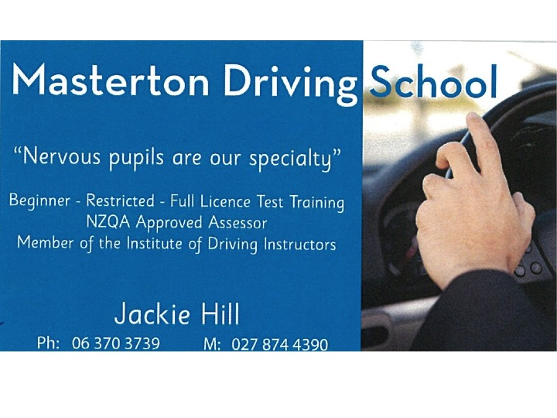
Thank you for attending RYDA. We hope you enjoyed the day and came away with some key messages. Thinking back on the day, please rate the modules as follows:
Crash Survivor:
 | Strongly Disagree | Disagree | Agree | Strongly Agree
The content / safety messages were relevant to me | 1 | 2 | 3 | 4
This module was engaging / enjoyable | 1 | 2 | 3 | 4
What I learnt will keep me and my friends safer | 1 | 2 | 3 | 4

I would have liked more information about: _________________________________________________________
___________________________________________________________________________________________
I would have liked less information about: __________________________________________________________
Stopping Distances:
 | Strongly Disagree | Disagree | Agree | Strongly Agree
The content / safety messages were relevant to me | 1 | 2 | 3 | 4
This module was engaging / enjoyable | 1 | 2 | 3 | 4
What I learnt will keep me and my friends safer | 1 | 2 | 3 | 4

I would have liked more information about: _________________________________________________________
I would have liked less information about: __________________________________________________________

Putting the ‘I’ in Drive:
 | Strongly Disagree | Disagree | Agree | Strongly Agree
The content / safety messages were relevant to me | 1 | 2 | 3 | 4
This module was engaging / enjoyable | 1 | 2 | 3 | 4
What I learnt will keep me and my friends safer | 1 | 2 | 3 | 4

I would have liked more information about: _________________________________________________________
I would have liked less information about: __________________________________________________________
Road Choices:
 | Strongly Disagree | Disagree | Agree | Strongly Agree
The content / safety messages were relevant to me | 1 | 2 | 3 | 4
This module was engaging / enjoyable | 1 | 2 | 3 | 4
What I learnt will keep me and my friends safer | 1 | 2 | 3 | 4

I would have liked more information about: _________________________________________________________
I would have liked less information about: __________________________________________________________

Hazards, Distractions & Risks:
 | Strongly Disagree | Disagree | Agree | Strongly Agree
The content / safety messages were relevant to me | 1 | 2 | 3 | 4
This module was engaging / enjoyable | 1 | 2 | 3 | 4
What I learnt will keep me and my friends safer | 1 | 2 | 3 | 4
Hazards, Distractions & Risks: (Continued)
I would have liked more information about: _________________________________________________________
I would have liked less information about: __________________________________________________________

Genevieves Story:
 | Strongly Disagree | Disagree | Agree | Strongly Agree
The content / safety messages were relevant to me | 1 | 2 | 3 | 4
This module was engaging / enjoyable | 1 | 2 | 3 | 4
What I learnt will keep me and my friends safer | 1 | 2 | 3 | 4

I would have liked more information about: _________________________________________________________
I would have liked less information about: __________________________________________________________

What was the most important message of the day for you? _______________________________________
___________________________________________________________________________________________

As part of our survey we also want to find out attitudes of young people to road safety and personal behaviour.
Behaviour
How often have you experienced these situations in a car in the last 6 months (on your own or with other young people)?
 | Never | Hardly  Ever | Some  times | Often | Very  Often
You were in a car and the driver (including you) was texting | 1 | 2 | 3 | 4 | 5
You were in a car and the driver (including you) was speaking on a mobile (hand-held) | 1 | 2 | 3 | 4 | 5
You were in a car and passengers were drinking (or had drunk) alcohol | 1 | 2 | 3 | 4 | 5
You were in a car and the driver was drinking (or had drunk) alcohol | 1 | 2 | 3 | 4 | 5
You were in a car going 5-9 km over the speed limit | 1 | 2 | 3 | 4 | 5
You were in a car going 10-19km over the speed limit | 1 | 2 | 3 | 4 | 5
You were in a car going more than 20km over the speed limit | 1 | 2 | 3 | 4 | 5
How often have you experienced these situations in a car in the last 2 months (on your own or with other young people)?
 | Never | Hardly  Ever | Some  times | Often | Very  Often
You didn’t wear a seat belt, even for a short trip | 1 | 2 | 3 | 4 | 5
You yelled or used rude gestures at another driver | 1 | 2 | 3 | 4 | 5
You were in a car, driving fast, just for the thrill of it (as either a driver or a passenger) | 1 | 2 | 3 | 4 | 5
You felt uncomfortable as a passenger about following too close to the car in front | 1 | 2 | 3 | 4 | 5
You almost crashed (either as a driver, or as a passenger) because of an in-car distraction (GPS, car radio, eating, putting on make up) | 1 | 2 | 3 | 4 | 5

Attitudes
When you are driving, how safe do you think you are?
 | Always Safe | Mostly Safe | Some  Times  Safe | Rarely Safe | Never Safe
Driving at 70 km/h in a 60 km/h zone | 1 | 2 | 3 | 4 | 5
Driving with a blood alcohol count just over the legal limit | 1 | 2 | 3 | 4 | 5
Driving in a poorly maintained car | 1 | 2 | 3 | 4 | 5
Driving in an old car (1 or 2 ANCAP stars, no airbags etc) | 1 | 2 | 3 | 4 | 5
Going through an orange light as it turns red | 1 | 2 | 3 | 4 | 5
Driving with two or more passengers | 1 | 2 | 3 | 4 | 5
Driving while texting | 1 | 2 | 3 | 4 | 5
Driving while talking on a handheld mobile | 1 | 2 | 3 | 4 | 5
Following the car in front too closely instead of the recommended gap | 1 | 2 | 3 | 4 | 5
Not wearing a seat belt correctly | 1 | 2 | 3 | 4 | 5
Of the following list, circle what you think are the top three unsafe driving behaviours or risks to young people
Texting Not wearing seatbelts Speeding Passenger distraction
In-car distraction Driver emotions/mood Loud music Overtaking
Hooning/racing Following too close Alcohol Nervousness
Fatigue Over-confidence Drugs

