Safe and Sustainable Travel Policy
This is a sample/template Policy – it should be adapted to your school situation.
Details which will vary per school are highlighted in yellow.

Information for all parents/whānau/caregivers

Hours
- School hours are: 8.55am – 3pm
- Students are asked not to arrive before: 8.30am
- After school care programmes are provided by/at:
- School does/does not close early on wet days/end of term/other

Entrances
The school has entrances at: .
Safe places to cross are at: .
- Patrolled Zebra crossing operates from: 8.30am-8.50am and 2.50pm-3.10pm
- Patrolled Kea crossing operates from: 8.30am-8.50am and 2.50pm-3.10pm
Mobility parking is available at: .
Drop off and pick up is available at: . (select which apply below)
- Drivers must not leave the car in the (Specify) zone – eg double yellow lines, driveways, obscuring school crossings etc
- Students must be ready to collect in the ‘Kiss and drop’ / pick up and drop off zone
- Please adhere to the parking time limits so other caregivers can also use these spaces.
On-site parking is provided for staff only and there is no access to the carpark between 8am-3.30pm.
Special notes: (e.g. routes to avoid, entrances which are off limits, etc)

We are an Active Travel (AT) school!
We encourage students to get some exercise on their way to or from school; students are encouraged to walk, bike, scooter, or skateboard. If it’s too far to walk or bike the entire way, park 200-500 metres from the school gate and walk the last bit. We also aim to celebrate AT during Movin’March and/or other AT activities and events each year.

Benefits to Students
- Increased physical fitness and health
- Improved focus on school and academic performance
- Enhanced sense of independence and confidence about their transportation and their neighbourhood
Parents are great role models for their kids: get active on your commute or during your trip to school!
- Progressive development of lifelong road safety skills

Benefits to the Community
- Improved road safety
- More community involvement as parents/whānau, teachers and neighbours put ‘eyes on the street’

Benefits to the School
- Students arrive alert and ‘ready to learn’
- Less congestion at the school gate, freeing up space for those who need to drive

Walking to School
We encourage students to walk for all - or part - of their journey to and from school. Younger children should be supervised by an adult or older sibling. It is up to parents’ discretion to decide when their children are able to walk to school independently. Students will be taught Road Safety as part of the curriculum/Keeping Ourselves Safe. Please ask if you have concerns about your child’s knowledge of road safety.

Park and Stride
Parents/caregivers are able to park in the [ ] car park/street. This avoids the congestion at the school gate and getting out of the surrounding streets. It’s a # minute walk from this location.
We provide parent/ teacher supervision for students to walk to the car park in the afternoon. Students who want to use this service need to assemble at the school gate by 3:05pm daily.
Older students may enjoy walking the last few blocks to school by themselves or meeting friends a few blocks from school. Talk to your children or their friends parents to arrange this.

Walking School Bus (WSB)
Parents of younger students can organise a Walking School Bus. Parent volunteers take turns walking a set route and picking up students on the way to school. For more information about setting up Walking School Buses, contact the school office or your local School Travel Planner.
- Our WSB travels from _____________ and the coordinator is:

Wheels
Any student riding a bike, scooter or skateboard to school must get their ‘Wheels License’ which says they agree to follow the safe cycling or scooting rules.

Scooters and skateboards (small wheels)
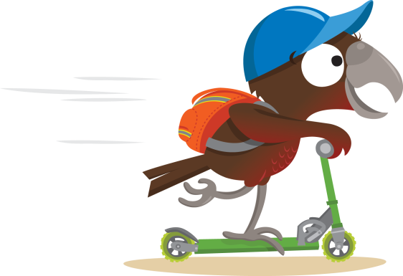
Our Small Wheels policy:
- A helmet would be advisable/must be worn.
- Scooters must be in safe working order.
- Students will wear closed-toe shoes while riding.
- Scooters must be stored in the designated space during the school day.
- Students agree to share with care – walk past pedestrians on narrow footpaths or give them a wide berth
- Control your speed – especially on steep slopes and past ‘sneaky’ driveways
- Walk across intersections and only cross at safe crossings
- Small wheels may/may not be ridden during breaks in the designated areas.

Cycling
The police recommend that children under the age of ten should cycle to school accompanied by an adult. However it is at the parents’ discretion to decide on a student’s ability to ride safely to school. Copies of the Road Code for Cyclists are available from NZTA or Wellington City Council and free cycle skills’ training is available from PedalReady.org.nz. Our year 5/6, 7/8 students will be doing grade 1 (basic skills) and grade 2 (on road training) in term __/every year.
Our Cycling Policy:
- Students cycling to and from school are expected to observe the road rules and have a good handle of basic skills – hand signals, looking behind, mounting/dismounting, keeping left, staying out of the car door zone, giving way to pedestrians in shared spaces, etc.
- Children biking to school must correctly wear a standards approved helmet.
- Bikes must be in safe working order and meet legal requirements.
- We recommend children wear bright clothing and closed-toe shoes at all times while travelling to and from school.
- Students may not "double" other students to school, and may not cycle in the school grounds during school hours, unless it is an organised school event.
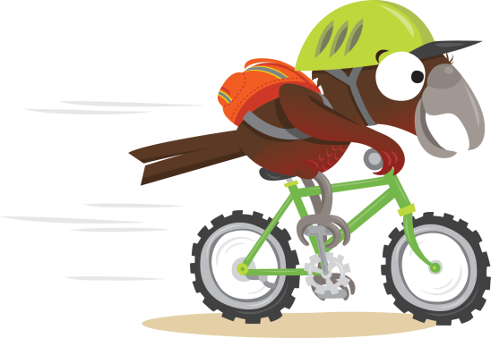
- We recommend children lock their bikes at school in the designated racks/space. Helmets are to be taken inside.
Reflective slap bands and backpack covers can be provided by Pedal Ready or Wairarapa Road Safety Council.

The school does not take any responsibility for children’s bikes or scooters.

Road Patrol
The New Zealand Police and our school work together to create the school traffic safety teams, which are run by students and supervised by adult volunteers. NZTA's site School Traffic Safety Teams provides comprehensive information, including a manual with helpful sections on setting up and operating a road patrol, coping with challenging conditions, and other resources.
If you notice any problems with the crossing equipment or signs please contact Wairarapa Road Safety Council on 06 377 1379, or email our school travel planner rsc@wairsc.org.nz.
Guidelines for our school
The XX Road crossing is patrolled between 8:30 and 8:55 am, and 3:00 and 3:15 pm.

Adult supervisors must:
- stand close to the leading patrol member so that they can communicate quickly and effectively in any emergency
- wear the appropriate gear and use all equipment correctly
- use their judgement to keep students safe as they use the crossing, and at times, must overrule patrol member's decisions
- record the details of any traffic offence occurring on the crossing, including registration numbers, time, weather and road conditions, and names of patrol members. Complete the offence notification form (contained in the School Traffic Safety Team Manual) and submit to your local police (email, phone, fax, post).

Students in the team must:
- complete their traffic safety training
- wear the appropriate gear and use all equipment correctly

Parents/caregivers:
Parents/caregivers are asked to cooperate with children who are on duty, model good behaviour at all times, and to encourage good road sense in their own children.
Parents who wish to help the school can be of great assistance by volunteering to be on duty one morning or afternoon per week, to free up teachers before and after school hours.
Please contact the school office if you can join the roster.

School Bus
For detailed safety and behaviour guidelines on school bus use, please see the Ministry of Education site: https://education.govt.nz/school/running-a-school/school-transport/safety-and-behaviour/

School Bus Policy:
Children
- Wait in the designated place or in a clear zone (with no hazards like power poles, drains, or trees), off the sealed road, and well back from the road.
- Wait until the bus has stopped and the door open before getting on or off.
- Listen to the driver and duty teacher's instructions.
- Carry bags in front, so they don't get stuck in the door.
- Get off the bus through the front door (if possible).
- Don't push.
- To cross the road, find a safe place, wait until the bus has moved away so you can see clearly in both directions, and then cross.
- If not crossing the road, stay as far left from the roadside as possible.
Caregivers
- Stick to the speed limit (20km per hour when passing a school bus on either side of the road).
- Try to eliminate the need for children to cross the road, or get out of the car in to passing traffic.
- Take children to and from the bus-stop.
- Teach children not to run across the road.
- Teach children how to get off the bus safely
Children can't be kicked off the bus
If a student is misbehaving on a bus, the driver can't pull over and remove them from the bus.
The driver has to finish the route and deliver all the students to their usual stops.
In extreme cases, if the driver decides it isn't safe to continue, they can pull over, call their employer, and then follow their employer's procedures (which may include calling the police).

Driving and Parking
Parking near the school is limited and should be prioritised for students who have mobility needs.
The roads around the school are busy. For the safety of all students, parents are asked to be prepared for unpredictable behaviour and lower their speeds; drive to the conditions.
Children should only exit the car on the kerb side – not into the flow of traffic. Children should not be encouraged to cross anywhere other than the approved crossings.
Illegally parked vehicles endanger other students by impeding visibility. This includes vehicles parked on broken yellow lines and over driveways. We will not tolerate dangerous driving or parking around the school.
Please note:
- Drop off and pickup zones must be used only if your children are ready to go. Drivers must not leave the vehicle.
- Please observe the no parking areas/broken yellow lines. No stopping at any time.
- It is both illegal and impolite to park in or over other people’s driveways to drop off or pick up children. Vehicles must be parked 1m from any vehicle entrance. Please do not use driveways to turn as you are endangering students walking on the footpath.
- Senior students, volunteers and staff may remind you about being incorrectly parked where student safety may be at risk.
- From time to time the Police or Masterton/Carterton/South Wairarapa District Council parking wardens monitor traffic behaviour and will issue tickets.
- No vehicles other than staff cars and approved delivery vehicles are permitted in the school grounds between 8.00am and 3.30pm.

Further information
- Wairarapa Road Safety Council school travel information: http://www.wairsc.org.nz/services/school-travel-plans
- Greater Wellington Active Travel resources: http://www.gw.govt.nz/getting-to-school/
- Pedal Ready bookings and information: https://www.pedalready.org.nz/schools
- NZTA active travel resources: http://education.nzta.govt.nz/feet-first
- School Traffic Safety Teams (Road Patrol): http://education.nzta.govt.nz/resources/policy-and-practices/school-traffic-safety-teams
- School traffic infringement report: http://education.nzta.govt.nz/__data/assets/word_doc/0008/59615/School-traffic-infringment-report.docx
- Further policy resources from NZTA: https://education.nzta.govt.nz/resources/policy-and-practices/road-safety-education-policy or https://education.govt.nz/school/property/state-schools/day-to-day-management/traffic-management/
- INSERT YOUR/Sample School Travel plan: e.g. http://www.frimley.school.nz/travel-plan/

